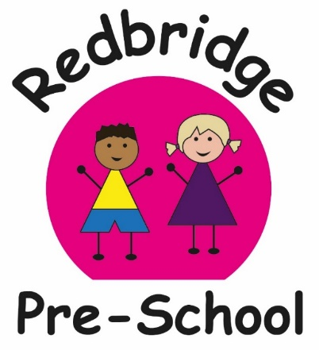

My name is…

My key person is…AMELIA

I am in …Seahorses….group

I am buddied with RED Group

My 1stTransition Time is 2pm on Wed 6h of Sept

**Each child will have their own settling in sessions tailored to suit their needs and help with a smooth transition. Please speak to your keyperson if you would like more transition days. about how you would like to do this and how long for.**

Jo- Pre school Manager and Safeguarding Lead

Red Group

Dawn (Deputy) Chelsea Mel Amelia

Blue Group

Michelle (SENDCO) Lisa Jemma Kelly

Kirsty- Admin and Finance

My Daily Routine

I come in and find my name peg to hang up my coat or bag. C:\Users\joanna\AppData\Local\Microsoft\Windows\Temporary Internet Files\Content.IE5\GIT56996\MC900044901[1].wmf.

Then I wash my hands for 20 seconds. When everyone is in,C:\Users\joanna\AppData\Local\Microsoft\Windows\Temporary Internet Files\Content.IE5\3YN9AC6Z\MC900140953[1].wmf my teacher will ring a tambourine so we know it is ‘Meet and Greet’ time. We sing our ‘Hello’ song, count everyone and listen to how everyone is feeling today. Then we go through our Golden Rules so we all know what is expected of us.

 Next I do a fun, small key group activity. This helps me make friendships. Then I get to choose to play with anything I like! I can run around outside, jump around in the Jabadao room, ride bikes, read books, play the drums or do some drawing…. There’s so much to do at pre-school! .

When Café Snack is open I get to choose when I would like to eat and drink, there is lots to choose from, there is even a menu! C:\Users\joanna\AppData\Local\Microsoft\Windows\Temporary Internet Files\Content.IE5\GIT56996\MP900438787[1].jpg

At the end of the session I help to tidy away all the toys. Sometimes I will get stickers or certificates for the fantastic things I do at pre-school! Then we all have a story before I go home! Then You can ask me what I have done!

Our Golden Rules

* We have friendly hands (They are gentle, they wave hello, they share the toys, they tidy away)
* We listen to everyone
* We wash our hands (when we come in, before we eat, after we have been to the toilet and when we go home.)
* We walk carefully indoors and run outside
* We tell someone if we are sad or hurt so they can help us. (and we help others too)
* We share our toys
* We have lots of fun! 

Understanding boundaries and what is expected of them helps children to settle and feel confident. Could you please help us teach your child these rules which they all helped to make.