Our action packed term! Exciting Times!
Enriching Lives!

DATES FOR DIARIES
What? | When?
Settling In Activities | September | We will be doing various friendship activities to help the children learn each others names.
Harvest festival | 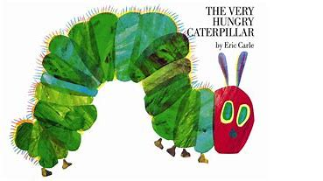  2nd -13th of October | The children will be peeling, chopping and vegetable printing.  Reading and learning the HUNGRY CATERPILLAR story and activities.
World Smile Day | Friday the 6^{h} of October | We will be singing the Laughing Song! Having a smiliest person competition and an award for the person who makes the most people smile!
Scarecrow making | 16th -20th of October | We will be making a Scarecrow at preschool. If you would like to join the fun and make one at home with your child we can display it!
Pumpkin Carving |  | All donations of Pumpkins welcome! Any shape and any size.  Pumpkin rolling competition! Medal for the furthest roll!
Half Term Holiday | 23rd - 27th of October | Pre-school will be closed
First day back after half term | Monday 30th of October | Autumn 2
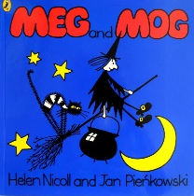 | 30th of Oct – 3rd of Nov | Children will be learning about Cats and Bats and Triangle Witches Hats with Meg and Mogs help!
Trick or Treat?! | Tuesday 31st of October  If your child is not in on this day they will be invited to a trick or treating session. | Spooky Happy Halloween! Children can come dressed up in their (friendly) Halloween outfits. Activities and Trick or Treating within pre-school.  £1 Donation gratefully received
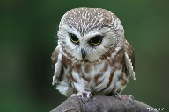  CSR Falconry | Thursday 2nd of November  At 9:00-10am | Claire will be bringing in a range of Owls and birds of prey for the children to see and hold.  If you would like to join in please pop along
INSET DAY | Friday 3rd November | Preschool will be closed
Bonfire Night Light display | 6th – 10th Nov | Chill out and relax in our jabadao room with sensory lights and sounds
Nursery Rhyme Week | 13th – 17th November | Activities will be based around rhymes Children will be focussing their play on characters from famous rhymes.  Children can come dressed as their favourite character throughout this week if they would like.
Nature Collecting  What can we hear? What can we see? What can we find? | 20th - 24th of Nov | Home challenge  Please can you collect fircones, holly leaves, twigs and anything Christmassy for us to investigate or make a wreatrhe with.
Photographer | Thursday 30th November at 1:00 | Say CHEESE!  Hallets will be in to take your child’s portrait.
Christmas Crafts and Stories | 27th Nov -15th December | Letters to Santa, tree decorations, Christingles, calenders, biscuits,
Christmas Dress up week | 11^{h}- 15th of December | FUNDRAISER £1 donations will be gratefully received, to go towards our Summer Trip to Paulton’s Park.  Children are welcome to dress up
Christmas Lunch | Wednesday 13th of December | Christmas Lunch and Christmas Crackers for lunchtime children. Information to follow.  Donations of £1 per child welcomed!
Last day of term | Thursday 14^{h} December | This is the last day of the children’s usual sessions
Jingle Bell Ball! Christmas Party for the children | Friday 15th of December  Times to be confirmed | Christmas Disco and tea party  Followed by a visit from Father Christmas  Invites to follow
CHRISTMAS HOLIDAYS | 18^{h} Dec- 2nd Jan
Inset Day-  No Pre-school | Tues 2nd of January | Pre-school is closed for the children
SPRING TERM  First Day Back after Christmas | Wed 3rd of January

If anyone has any more enriching ideas we can do to promote our children’s learning experiences please let us know.

