‘Friends, Families, Fun’

Table of Contents
Welcome to Redbridge Pre School 3
Mission Statement 3
Learning Through Play 4
Our Staff 6
Key people 7
Curriculum- Early Years Foundation Stage 8
Redbridge Pre-School- Children’s Progress 9
Timetable and Routines 10
Safeguarding children 12
Special Educational Needs and Disability (SEND) 12
Committee 13
Policies 14
Data Protection 14
Working together for your children 18
Breakfast and Snack Times 19
Healthy Eating 20
Teeth Cleaning 21
First Aid 21
Medication 22
Health, Safety & Hygiene 22
Guidance on Infection Control 23
Fees & Funding 27
3-Year-Old Funding 28
2-Year-Old Funding 29
30 Hour Funding- For working parents 29
Child absences 31
Opening Hours 31
Dropping off and Collecting your Child 32
Starting our Pre School 33
Miscellaneous 33
Complaints 34
Privacy notice 35
OUR CONTACT DETAILS 39
Your Comments 40

Welcome to Redbridge Pre School

Welcome to Redbridge Preschool. Thank you for showing an interest in our preschool. We hope that your child will have a happy enjoyable time with us.

This prospectus aims to provide you with an induction about how Redbridge Pre School is run. Our pre-school has been a well-established pre-school for over 20 years.

Our latest inspection was July 2019, which we were graded ‘OUTSTANDING’. A copy of our full report can be found here https://reports.ofsted.gov.uk/inspection-reports/find-inspection-report/provider/CARE/EY262068
or on our website www.redbridgepreschool.co.uk

We are a member of the Early Years Alliance.

Mission Statement

These are the aims of the staff and committee members of Redbridge Pre-School.

- To provide a high quality of care and education for children through enriching experiences of play

- To support children and their families in a friendly enabling environment, to promote their full potential and obtain sustainable life skills

- To promote high self-esteem, confidence and independence to the children and their families for them to be able to flourish further in life

- Offer children and their parents a service that promotes equality and values diversity

Learning Through Play

Children start to learn about the world around them from the moment they are born and at home with their parents. The care and education offered by Redbridge Pre School aims to continue this style of gentle nurturing to extend the children’s learning with interesting activities that are appropriate for their age and stage of development.

All our learning is play based, with most activities being child led, only a few are led by an adult.

The freedom of allowing children to play comes with many benefits
- Essential for children to extend their skills
- Develops their confidence
- Build upon what they already know.
- Deepens their understanding.
- Develops their independence and ability to make choices
- Enables the children to take risks & solve problems
- Think creatively and imaginatively.

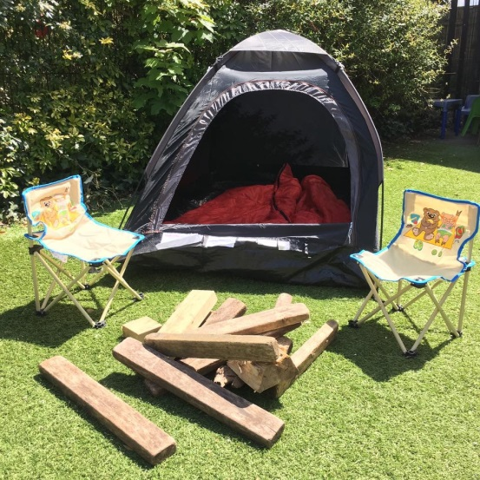
The ‘doing and talking’ at their own pace is paramount to extending their learning and development.

It is important that children do not experience formal teaching at Pre-School as this can inhibit the child’s imagination, creativity and put them off the learning experience when they are at school level. The best foundations for learning are to give the child as many play experiences as possible in their first few years.

Our setting uses the Early Years Foundation Stage to plan and provide a range of play activities and enriching experiences to promote development.

We deliver early year’s curriculum through:

- Heuristic Play – a type of play that encourages children to explore the possibilities of natural objects
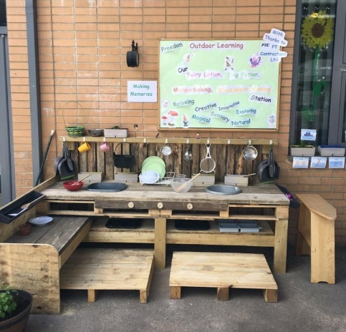
- Role Play - dressing up clothes, playhouse, puppets
- Physical Development - cars, bikes, balls, climbing frame
- Construction – bricks, Lego, planks, large crates to climb etc
- Stories - books
- Literacy
- Numeracy
- Mark Making, creative painting and modelling skills
- Water, sand, and malleable materials.
- Jabadao Room (sensory soft play)
- Mud Kitchen
- Planting & Pruning flower beds

As part of promoting children’s health children can access the garden in all weathers. We can provide waterproof outdoor clothes. The exercise and fresh air help aid concentration and positive behaviour.

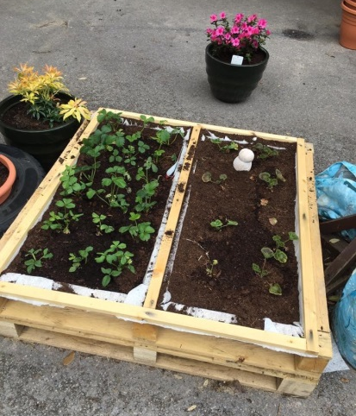

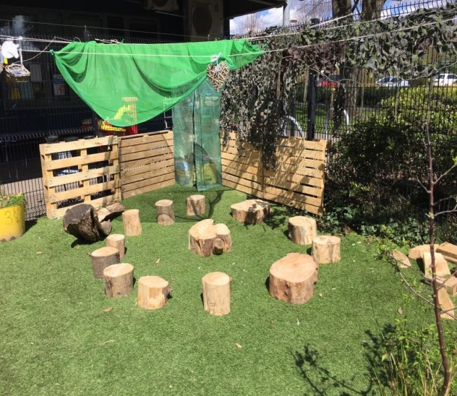
Our Staff

Staff at Redbridge Pre-school have many years of experience. There is a content, relaxed atmosphere set by staff, which we hope will reflect on your child.

All staff and volunteers are cleared through the Enhanced Disclosure and Barring service (DBS) to ensure they are suitable to work with children.

Joanna | Manager  Designated Safeguarding Lead  Health & Safety  Mental Health Lead | BA Hons EY
Dawn | Deputy Leader  Designated Safeguarding Lead | NVQ 3
Michelle | SENDCO and Room leader | NVQ 3
Melissa | Practitioner | NVQ 3
Kelly | Practitioner | NVQ 3
Chelsea | Practitioner | NVQ 3
Lisa | Practitioner | NVQ 3
Amelia | Practitioner | NVQ3
Jemma | Play Practitioner | NVQ 2
Kirsty Giffen | Finance & Payroll | NVQ 3 IT & Admin

Other mandatory qualifications include: * Food safety & hygiene * 1st Aid
- Safeguarding

As well as gaining qualifications in early years, care and education, the setting staff take part in further training to help them to keep up to date with the latest theories and new procedures. Certificates can be viewed upon request if you would like to see them.
The setting also keeps itself up to date with best practice as a member of the Early Years Alliance, through the Under 5 magazine and publications produced by the Alliance. The current copy of Under Five is available for you to read.
We get support and training via Southampton City Council; our Early Years Advisory Teacher is Liz Smith, and our Development Worker is Belinda Cone

Key people

Your child will be allocated a Key Person to form a bond with to help the transition from home to pre-school. The key person is there for you to share any information regarding your child and will help with your child’s development, progress, targets, and confidence.

All key people are split into 2 groups, Red Group and Blue Group. (These are highlighted on the chart in the staff section). These groups act as teams, so they can share information regarding your child’s development so each child has more people looking after them and the children can buddy up with more children.

If your key person isn’t in, another team member of staff will be allocated to look after your child for that day.

We hope to establish a close liaison between staff and all parents as this will give the children a feeling of security and confidence.
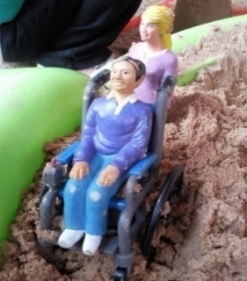
Before your child starts pre-school, you will be invited to come and meet your key person and discuss their needs and wants and fill out the ‘My Unique Child’ book and take a look at Every Child is a Talker information sheet to see what you child can do.

Key people will document the children’s play in an online journal application called Tapestry where you can view pictures of the activities your child has been doing.

We aim to ensure that each child:

- is in a safe and stimulating environment.
- is given generous care and attention, because of our ratio of qualified staff to children as well as volunteer helpers
- has the chance to join in with other children and adults to live, play, work and learn together.
- is helped to take forward their learning and development by being helped to build on what they already know and can do.
- has a key person who makes sure each child makes satisfying progress;
- is in a setting that sees parents as partners in helping each child to learn and develop; and
- is in a setting in which parents help to shape the services it offers.

Curriculum- Early Years Foundation Stage

Provision for the development and learning of children from birth to 5 years is guided by the Early Years Foundation Stage (EYFS). We aim to reflect four overarching principles in our practice

- A Unique Child
Every Child is a unique child who is constantly learning and can be resilient, capable, confident, and self-assured.

- Positive Relationships
Children learn to be strong and independent through positive relationships, with their key person, peers, and other team members. There is a strong partnership between practitioners, parents, and carers.

- Enabling Environments
Children learn and develop well in an enriching, enabling environment tailored to their individual needs.

- Learning and Development
Children develop and learn in different ways and at different rates. The framework covers the education and care of all children in early years provision including children with specific educational needs and disabilities.

The Progress Check at age Two

Between the age of 24-36 months The Early Years Foundation Stage requires us to write a summary of your child’s development in the three prime areas of learning and development, –

- personal social and emotional development.
- physical development; and
- communication and language

Your child’s key person is responsible for completing the check using the information from on-going observational assessments conducted as part of our everyday practice, taking account of the view and contributions of parents and other professionals.

Redbridge Pre-School- Children’s Progress

This is how we keep track of our children’s progress
- We read the Unique Child booklet and Every Child A Talker sheets that the parents and guardians have filled out. We believe parents and guardians know their children best. This is needed so staff can help care and plan for their child.
- Using our professional knowledge and information from parents we decipher a Baseline Assessment
- From these we devise Next Steps (target) with the parents and help the children to work towards these. We believe each child should have their own starting point and not be judged against other children.
- The children have Target Stamp charts which they stamp to help them to monitor their own progress. We believe children’s learning becomes embedded when they have an element of control and understanding of their own learning. When this is full the key person and parents or child choose another one.
- Key people plan for the children and set up small key group activities each day to support the children’s social skills and friendships and to help the children’s development progress. We believe each child should have an individualised education plan and key group activities help to strengthen friendships.
- We use the Tapestry Online Learning Journal to record the children’s observations and photos and endeavor to upload one per week. We can monitor development and signpost to early support if necessary.
- Parents are welcome and encouraged to add observations to the children’s Tapestry Online Learning Journal as well as staff members. So, the children can view their photos and see what they have been doing.
- We celebrate children’s progress by giving them ‘WOW’ certificates for them to take home and put on their key group boards. Children’s learning is enhanced by celebrating and remembering positive experiences. Parents are encouraged to bring in some WOW moments for the boards or upload them to Tapestry too.
- The children contribute to their boards by writing down their achievements and what they are proud of (annotated by staff).
- Each term the keyperson fills out the ‘2 Stars and a Wish’ sheet to encourage children to be aware of 2 achievements they have made and 1 thing they would like to learn. This helps to boost children’s self-esteem, and enhances a ‘Can do’ attitude to learning
- We do an ECAT audit twice a year to help us spot any areas to develop within the children’s speech and language skills to help us support children who may not be on track.
- We plan activities and provide an Enabling Environment to help the children to Enjoy and Achieve.
- We discuss the children’s progress at each session. Parents can opt to have 1:1 meetings to discuss their child’s development and Celebrate their Progress.

Timetable and Routines

Children arrive and put their coat on their coat peg. Wash Hands
Free play
Meet and Greet
Key group activity
Free play Café snack will be open for an hour so they can choose when to eat
Teeth cleaning
Tidy up time
Small group story

At Redbridge Pre School we believe that care and education are equally important in the experience which we offer children. The routines and activities that make up the day in our setting are provided in ways that:

- Help each child to feel safe and know what will happen throughout the session
- feel valued as member of the Pre School.
- ensure the safety of each child.
- help children to gain from the social experience of being part of a group; and
- provide children with opportunities to gain experience and help them to value learning.

Safeguarding children

Safeguarding is everyone’s business.

Our Safeguarding Designated Officers are Jo and Dawn.

Our setting has a duty under the law to help safeguard children against suspected or actual ‘significant harm’.

We work closely with children and their parents so we can offer support as early as possible. We can refer families to the Early Help Hub for extra professional support for a range of circumstances, such as problems with housing, financial difficulties, or domestic abuse.

Occasionally children may need to be referred to our local Safeguarding Team based in town, to help the parents to meet their needs.

We have robust employment policies and laws to follow to ensure no child comes to harm within the setting. We have a procedure for managing complaints or allegations against a member of staff and will contact our Local Authority Designated Office for guidance.

If you have any concerns about any child, please phone Southampton Safeguarding Team on 02380 833336.

Special Educational Needs and Disability (SEND)

We take account of any special needs an individual child may have and make sure our provision adapts the setting to meet their need. The setting works to the requirements of the Special Educational Needs and Disability Code of Practice: 0 to 25 years (2020).

Our SENDCO is Michelle Frampton

For further information on our SEN Local Offer please find our advert on the SID website Southampton Directory | Redbridge Pre-School

Committee

Redbridge Pre School is a registered charity, and we are run by a parent-based management committee. We use the Early Years Alliance EYA Constitution, which requires us to have a management committee, so we depend upon the good will of parents and their involvement to be able to stay open.

What is a Committee?

The committee is a group of people who come together to make decisions about the running of the setting.

Our committee members are elected at our Annual General Meeting by the other parents.

The committee make up the Registered Person with Ofsted and are responsible for:
- managing the setting's finances.
- employing and managing the staff.
- making sure that the setting has, and works to, policies that help it to provide a high-quality service; and
- making sure that the setting works in partnership with the children's parents.

All parents of children who attend the setting should attend our Annual General Meeting. (approx. 15 minutes). We look back over the previous year's activities and the coming year's plan. This is then reported to the Charity Commission.

It is a great way for parents to work together with the staff to share ideas and help with fundraising events.

The committee regularly discuss the finances such as how much is in the bank, spending, equipment, bills, and rent; employment and managing staff, making sure the setting works in partnership with parents and keeping everyone up to date with the children’s activities. The committee also ensure the setting work to the policies that help it to provide a high-quality service.

Our Current Members are:

Louise Bettany | Chairperson
Shannon Rowlands | Treasurer
Ann-Marie Wiseman | Secretary
Kim Hudson-Collier | Committee Member
Ebony Streak | Committee Member
Sally Severn | Committee Member
Sarah Bailey | Committee Member

If you would like to join the Committee, or attend any of our meetings, please do come along. Texts are sent out to all parents informing you of the dates and times of meetings.

If we don’t have parents joining our committee the preschool will have to close.

Policies

Copies of the setting's policies and procedures are in our office and are available for you to see at the setting. They are also on our website for easy access. These are working documents and are reviewed regularly.

The setting's policies help us to make sure that the service provided by the setting is consistent and a high quality one, to make sure that being a member of the setting is an enjoyable and beneficial experience for each child and their parent.

The staff and parents of the setting work together to adopt the policies and they all have the opportunity to take part in the annual review of the policies. This review helps us to make sure that the policies are enabling the setting to provide a quality service for its members and the local community.

Data Protection

Information we hold about you and your child

We have procedures in place for the recording and sharing of information (data) about you and your child that is compliant with the principles of the General Data Protection Regulations (2018) as follows:

The data we collect is:

- Processed fairly, lawfully and in a transparent manner in relation to the data subject (you and your family)
- Collected for specified, explicit and legitimate purposes and not further processed for the other purposes incompatible with those purposes
- Adequate, relevant, and limited to what is necessary in relation to the purposes
- Accurate and, where necessary, kept up to date
- Kept in a form that permits identification of data subjects (you and your family) for no longer than is necessary for the purposes for which the personal data is processed
- Processed in a way that ensures appropriate security of the personal data including protection against unauthorised or unlawful processing and against accidental loss, destruction, or damage, using appropriate technical or organizational measures.

We provide our parents / carers with a copy of our Privacy Statement and Policy when they register their child.

You have the right to withdraw consent at any time and you have the right to access yours and your child’s personal information held by us.

Our Data Protection Lead is Joanna Watson-Gray

Privacy Notice - Data Protection
Information about Children in Early Years Providers

We, Redbridge Pre School are a data controller for the purposes of Data Protection. We collect information from you and may receive information about you from your previous Early Years Provider or education provider, local authorities and the Department for Education (DfE).

A great deal of the information we collect is included in the Parent Declaration Form, completed on your child’s admission to an Early Years Provider which, when signed, indicates that you understand how your families data will be processed. In addition, we collect information for 30 hours eligibility, 2 year old funding eligibility, on learning and development, on safeguarding and welfare & special educational needs and disabilities.

We hold this personal data and use it to:

- Support teaching and learning. In order to facilitate this, we may share information with the software supplier (listed at the end of this document) to set up the systems needed for children and parent/carers to access. When your child applies for a school place, information may be forwarded to your child’s new school to aid transition into their next phase of education. If your child changes Early Years Provider or attends more than one provider, information may be shared between Early Years Providers.
- Monitor and report on learning and development.
- Provide appropriate pastoral care (Keeping Children Safe in Education 2016).
- Assess how well we, as an education provider, are doing.
- Co-operate with Southampton City Council and external partners to improve the well-being of children, under the duty of the Children Act 2004. Working Together to Safeguard Children (2015)
- Share information with Southampton City Council and external partners to support the duty to safeguard and promote the welfare of children, under the Children Act 1989, Section 17. Working Together to Safeguard Children (2015)
- Provide information via statutory census returns to the DfE and in turn this will be available for the use of Southampton City Council to carry out its official functions, or a task in the public interest.
- Send Child level information to Southampton City Council on a regular basis in accordance with our information sharing agreement to enable the local authority to meet its duty under Data Protection legislation to ensure that the data it holds is accurate and also to carry out its official functions, or a task, in the public interest.

Your information will not be used for any other purpose or shared with any other organisation unless provided for by law or covered in this Privacy Notice.

The Early Years Provider’s member of staff responsible for data protection, who should be contacted in writing if you would like to receive a copy of the information about you that we hold or share, is:

Jo Watson-Gray 02380 764211

For information on how long the Early Years Provider will store the information collected please refer to the providers Retention of Records Policy.

Should you have any concerns with how your data is being processed, the following steps should be taken:

Step 1: Contact the Early Years Provider Data Protection Officer.
Step 2: If concerns remain unresolved, follow the Early Years Provider Complaints procedure.
Step 3: Contact the Information Commissioner's Office (www.ico.org.uk)

For further information on the circumstances under which you have the right to request access to, or rectification\erasure of, your personal data please visit the Information Commissioner’s website.

Southampton City Council has a duty under the Children Act 2004 to co-operate with their partners in health and youth justice to improve the wellbeing of children in their area and will agree information sharing agreements with partners to enable them to carry out official functions, or a task in the public interest.

The DfE may also share child level personal data that we supply to them, with third parties. This will only take place where legislation allows it to do so and it is in compliance with the data protection principles. Decisions on whether DfE releases this personal data to third parties are subject to a robust approval process and are based on a detailed assessment of who is requesting the data, the purpose for which it is required, the level and sensitivity of data requested and the arrangements in place to store and handle the data. To be granted access to child level data, requestors must comply with strict terms and conditions covering the confidentiality and handling of data, security arrangements and retention and use of the data.

For more information on how this sharing process works, please visit: https://www.gov.uk/guidance/national-pupil-database-apply-for-a-data-extract

For information on which third party organisations (and for which project) child level data has been provided to, please visit: https://www.gov.uk/government/publications/national-pupil-database-requests-received

If you require more information about how the Local Authority (LA) and/or DfE store and use your information, then please go to the following websites:
- www.youngsouthampton.org/privacynotice.aspx and
- http://media.education.gov.uk/assets/files/doc/w/what%20the%20department%20does%20with%20data%20on%20pupils%20and%20children.doc
- http://www.education.gov.uk/researchandstatistics/datatdatam/b00212337/datause

If you are unable to access these websites we can send you a copy of this information. Please contact the LA or DfE as follows:
- Solicitor for Education: Legal Services, Southampton City Council, Ground Floor, Civic Centre, SO14 7LY
- Public Communications Unit: Department for Education, Sanctuary Buildings, Great Smith Street, London, SW1P 3BT
Website: www.education.gov.uk
Email: www.education.gov.uk/help/contactus
Telephone: 0370 000 2288

Provider postal address
Provider e-mail address
Provider telephone number
Software supplier | Capita, Tapestry, Open Objects.

Working together for your children

In our setting we maintain the ratio of adults to children in the setting that is set through the Welfare Requirements.

We also like to have volunteer parent helpers where possible to complement these ratios.

This helps us to:

- give time and attention to each child.
- talk with the children about their interests and activities.
- help children to enrich the children’s experience and
- allow the children to explore and be adventurous in safety.

From time to time the setting holds learning events for parents. These usually look at how adults can help children to learn and develop in their early years.

We have had workshops with tips to promote children’s speech and one to help parents understand the curriculum we follow. If there is anything you would like more information about, please ask.

How parents take part in the setting

You are regarded as members of our Pre School, who have full participatory rights. These include a right to be:

- valued and respected.
- kept informed.
- consulted.
- involved; and
- included at all levels

Our setting recognises parents as the first and most important educators of their children. All the staff see themselves as partners with parents in providing care and education for their child. There are many ways in which parents take part in making the setting a welcoming and stimulating place for children, such as:

- exchanging knowledge about their children's needs, activities, interests and progress with the staff.
- helping at sessions of the setting.
- sharing their own special interests with the children;
- helping to provide, make and look after the equipment and materials used in the children's play activities;
- being part of the management of the setting.
- taking part in events and informal discussions about the activities and curriculum provided by the setting.
- joining in community activities in which the setting takes part; and
- building friendships with other parents in the setting.

Joining In

If you would like to pop in and help, read a book or show a new skill, please speak to Jo to arrange a time when you can come in. Parents can offer to take part in a session by sharing their own interests and skills with the children. Parents have visited the setting to play the guitar for the children, show their nursing equipment so they could listen to their hearts beat, and we have had shredded snakeskin brought in.
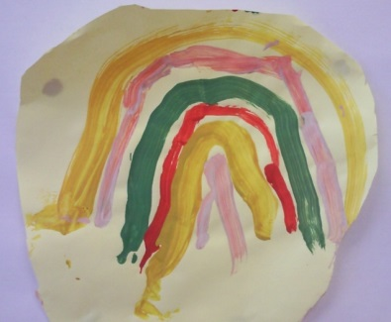
Helping at the session enables parents to see what the day-to-day life of the setting is like and to join in helping the children to get the best out of their activities.

Breakfast and Snack Times

Dawn has been awarded The Healthy Early Years Award and devises a healthy menu for us which is rotated on a 4-weekly cycle.

We have a cafe style snack so the children can independently choose when they need it and to make it a sociable occasion.

We offer breakfast-based snack in the morning. The children are offered either cereal, breads, crumpets, fruit & yogurts. For the afternoon snack, the children are offered things like breadsticks, crackers, cheese, vegetables, or sandwiches. All these are low in fat, sugar, and salt. At the beginning of each term parents are given a menu of the snack offered.

During the year we also offer different types of multi-cultural foods as part of snack such as, noodles, pitta bread, naan bread and exotic fruits.

We offer the children milk or water to drink during snack and lunchtimes.

The water station is available all day, where the children are welcome to help themselves.

Please do not send in snack or drink with your child unless they have specific dietary requirements. This is due to other children’s allergies.

Please tell us about any dietary needs and we will plan accordingly.

To help keep the cost down, a small donation is very much appreciated.

Due to possible allergies, we ask that Lunch children don’t bring in Peanut Butter, nutty cereal bars, or chocolate spread. Thank you

Healthy Eating

We are Redbridge Preschool. We encourage Healthy Eating!!
At Redbridge Preschool we want to make a positive contribution to the health and wellbeing of our Children, Families and Staff and teaching the effects of a healthy lunch are beneficial. Eating healthily can help a child be more awake and alert, which aids concentration and promotes positive behaviour. It also lowers the risk of heart and weight problems.

Healthy Lunch Box Ideas

* A variety of sandwiches, rice or pastas
* A variety of vegetables and fruits
* Dairy products such as cheeses, yoghurts
* Remember it is best for your child to drink water or milk and please include a drink to provide hydration.

PLEASE PROVIDE YOUR CHILDS LUNCH IN A LABELLED LUNCH BOX SUITABLE FOR THE FRIDGE OR SO AN ICE PACK CAN FIT INTO IT.
Cut
sandwiches
into shapes
Instead of bread use pitta bread, bagels, granary or wholemeal

Please no: Fizzy Drinks, Sweets, or Chocolate

We ask for only 1 treat, either a biscuit, crisps or cake

PLEASE DO NOT INCLUDE NUTS
(Including peanut butter & chocolate spread) DUE TO ALLERGIES
Staff also have the right to remove unsuitable items for lunch boxes, please see our policy.
Visit www.eatwell.gov.uk for more information.

Teeth Cleaning

Each session children clean their teeth after they have eaten snack. Each child is given a toothbrush with their names on and these are stored in containers ensuring no cross contamination and renewed every 6 months.

We are lucky to have all our toothbrushes and toothpaste donated to us by SureStart at Pickles Coppice.

First Aid

If a child has been hurt, they will be comforted, correct 1st Aid administered by a qualified 1st aider and any incidents will be written in the accident book.
The guardian picking up will be asked to sign our accident book.

Medication

We are only able to administer medication and lotions that have been prescribed by a doctor. Each medication will have to be written about and signed by the parent in our medication book.

Administration of all medication or lotions will be done by two members of staff to ensure the accuracy of the dosage and timing. The staff will then sign it to show that it has been given.

If your child becomes poorly at preschool, we will phone you to come and collect them.

.

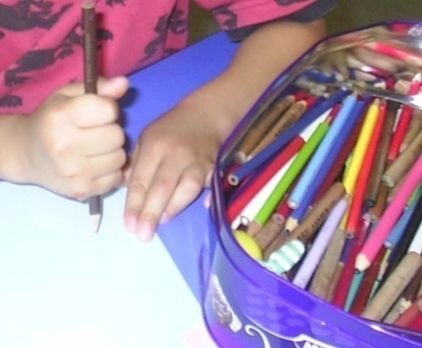

Health, Safety & Hygiene

Fire Drills and Lock down

Fire Drills and Lock Down will be taken place at the beginning of each term for a week to ensure all children know what the fire drill is and what actions to be taken.

For the Fire drill- our meeting point in under the tree on the green by Cuckmere Lane (still inside the community school campus)

For the lock down procedure- children will be brought in to the building. The doors and windows will be shut and locked, to protect them for whatever may be going on outside.

GOOD HYGIENE PRACTICE

Coughing and Sneezing easily spread infections. Children and adults should be encouraged to cover their mouth and nose with a tissue. Wash your hands after using or disposing of tissues down the toilet. If you don’t have a tissue, you should cough or sneeze into your arm, never your hands. Spitting should be discouraged.

Cleaning of the environment, including toys and equipment should be frequent, thorough, and following national guidance e.g., use colour coded equipment, COSHH, correct decontamination of cleaning equipment. Monitor cleaning contracts and ensure cleaners are appropriately trained with access to Personal Protective Equipment PPE

Cleaning of blood and body fluid spillages All spillages of blood, faeces, saliva, vomit, nasal and eye discharges should be cleaned up immediately (always wear PPC) When spillages occur, they are cleaned using a product which combines both a detergent and disinfectant. We use as per manufacturer’s instructions and ensure it is effective against bacteria and viruses, and suitable for use on the affected surface. We NEVER USE mops for cleaning bloody and body fluid spillage, instead we use disposable paper towels and discard clinical waste safely. A spillage kit should be available for blood spills.

Personal Protective Equipment (PPE) Disposable non powdered vinyl or latex free CE marked gloves and disposable plastic aprons must be worn where there is a risk of splashing or contamination with blood/body fluids. (E.G., nappy or pad changing) Goggles should be also available for use if there is a risk of splashing to the face. Correct PPE should be used when handling cleaning chemicals.

Animals may carry infections so wash hands after handling animals. Children do not play with animals unsupervised. Reptiles are not suitable for children’s to hold as all species carry salmonella.

Guidance on Infection Control

If your child comes down with any illnesses, please see this guidance as sometimes children are not permitted into preschool, to prevent it from spreading to other children and staff.

 | Recommended period to be kept away from setting | Comments | Pictures
Corona Virus Covid 19 | Children must be kept off if they have a temperature . If a test is positive they must not attend preschool for 3 days after the test | Due to the changing guidelines please see current Government updates
Chicken Pox | 5 days from the onset of the rash and until all blisters have crusted over | Can return to setting when they feel well.
Cold Sores  (Herpes simplex) | Until they have dried up. | Avoid kissing and contact with the sores. Cold sores are generally a mild self-limiting disease
German Measles (rubella) | 5 days from onset of rash | The MMR Vaccinations can prevent this. Please make sure your child has it before preschool.
Hand, foot and mouth | 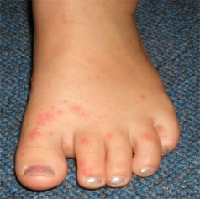  If your child is unwell | Contact HPT if a large number of children are infected. Exclusion may be considered in some circumstances
Impetigo | 48 hours after the start of anti-biotics. Or Until lesions are rusted or healed | Anti biotics speeds the healing and reduces the infectious period
Measles | 4 days from onset of rash and when the child is well enough. | Preventable by having the MMR vaccine
Ringworm | Until treatment commenced | Treatments are important and are available from pharmacist. Also check and treat symptomatic pets
Athletes foot | Child can come in | Must keep socks on
Diarrhoea and/or vomiting | 48 hours from last episode of diarrhoea or vomiting | Children must stay at home
Head Lice | Until live lice have been removed.  Failure to treat head lice may be considered a safeguarding concern under the Neglect category. | Close contacts should be checked and treated if live lice are found.  Regular detection (combing) must be carried out by parents.
Conjunctivitis | If it is bacterial-Couple of days until better | Sometimes is caused by an allergy not infection. Will see red, sore, inflamed & itchy eyes  Hand washing after toilet, before food, after food, if been in garden, if handled animals, sneezing, blowing of nose, before and after medical treatment. I.e., applying a plaster, and messy play etc. | 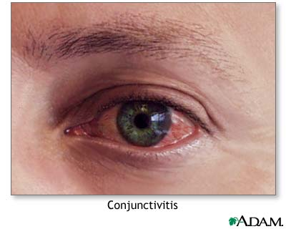  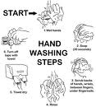
Croup | If the child feels unwell. | Affects children under the age of 4. Will have a violent, barking cough, wheezing and breathing difficulties. Seek medical advice
Meningitis | Until they have recovered  (None if viral meningitis) | Preventable by vaccination .
MRSA | None | Need good hygiene and hand washing
Scabies | Must seek medical advice and be kept away from school until treatment has started | Highly contagious.  Family members need to be treated aswell
Whooping Cough | 2 days from starting antibiotics. Or 21 days from the onset of symptoms if no antibiotics | Preventable by vaccine
Thread Worms | Children can come back when clear | Recommended to treat the whole family | Seek medical advice or for treatment.
Tonsilitis | Children can come in if they are well enough.
Tuberculosis | Until at least 2 weeks after the start of effective antibiotic treatment | Always consult the Health Protection Team
Warts and Verrucae | None. | Verrucaes must be kept covered
Mumps | 5 days after the onset of swelling | Preventable by vaccination
Scarlet fever | Exclude until 24 hours after starting treatment | If not anti biotics a person is infectious for 2-3 weeks
Slapped Cheek | None once the rash has developed | If pregnant consult Midwife
Diptheria | Exclusion is essential Follow guidance from Health Protection team | Preventable by vaccination. See GP
Flu | Whilst the child is unwell
Glandular fever | None
Hepatitis A | Exclude for 7 days after onset of jaundice | Contact HTP in an event of an outbreak
Hepatitis B, C and HIV | None | Blood borne viruses that are not infectious through casual contact. Contact HPT for more advice.

To Protect your child please make sure they are up to date with all the current vacinations before starting preschool

Fees & Funding

Fees

Our current fees are:

- £19 per session – 8:30-11:30 or 12:15-3:15pm
- £6.50 per lunch club 11:30-12:15pm
- £5 per breakfast club – includes breakfast. 8-8:30am
- £3 per after school club. 3:15-3:30pm

Fees must be paid in advance. Fees are chargeable even if your child is off for any reason, e.g. sickness or holidays. We do not charge if we need to close the preschool.

We send out a termly invoice. Please use this to decide if you want to pay weekly, monthly, or termly in advance. Please do not pay in arrears.

We ask parents to pay by Standing Order. Termly invoices will have individual reference numbers on them.

HSBC Account no – 10690775 Sort Code – 40-44-25

For queries about fees please email Vicky at info@redbridgepreschool.co.uk

Outstanding payments

If fees fall 3 or more weeks in arrears, then any non-funded or additional sessions may be cancelled. If you do have any payment problems, please do speak with Vicky, who is always happy to help where possible. Weekly fees texts are sent to parents to remind them of amounts due.

Funding

3-Year-Old Funding

In the term after your child’s 3rd birthday, they are entitled to 15 hours a week free government funding/ 570 hours a year.

Birthday cut off dates each term are:

31st December
31st March
31st August
Our Terms run:

September – December - Autumn
January – March - Spring
April – July - Summer

I.E – child’s birthday 5th October, the first term after this would be the spring term (January)

Breakfast club, lunch club and afterschool club can be used it your child’s Government funded hours as well as the normal sessions

2-Year-Old Funding

Your child may be eligible for funding from the term after their 2nd birthday. please go to www.southampton.gov.uk/2yearfunding where you can apply for a code. We will need the code before they start, or you will have to pay for their sessions.

30 Hour Funding- For working parents

This is a fantastic opportunity for working parents to have more childcare funded by the Government. For those parents that will be eligible this will give their children an additional 570 hours a year funded hours.

Criteria

- Single Parent Family – the parent must work the wage equivalent of 16 hours a week at their minimum wage.

- Two Parent Families – both parents must work the wage equivalent of 16 hours a week at their minimum wage for their age. However, if one parent has caring responsibilities, is disabled or on maternity leave, the family may still be eligible.

- This includes self-employed and zero hours contracts.

- Children become eligible in the term after their 3rd birthday.

- In cases where parents are separated, eligibility applies to the parent whom the child ‘normally lives. Where the parent of a child has a ‘partner’ I –e a person to whom they are married, have civil partnership, or live with, the eligibility criteria also applies to that partner.

Visit www.childcarechoices.gov.uk to apply for your code

- The code can be applied one term before using it but needs to be used within 3 months or a new code will have to be applied for.

- Please then email the code, along with your National Insurance number to info@redbridgepreschool.co.uk so that we can confirm the code with our Southampton City Council funding portal.

- Every 3 months Pre School will complete a check to ensure your code is still valid, however if you lose your job or work circumstances change you have a small ‘grace’ period. If your claim is to be stopped, your child’s hours will drop to 15 hours, or you can keep the hours but will be charged at our Fees rates.

- You will need to re validate your code every three months via your HMRC account. Failure to do this will result in your additional funding stopping the following term or after your Grace Period end date.

Tax Free Childcare

Websites:
www.childcarechoices.gov.uk this website includes a childcare calculator for parents to compare all the government’s childcare offers.

https://www.gov.uk/government/news/uk-families-will-soon-see-bills-cut-as-date-announced-for-the-launch-of-tax-free-childcare
How Tax-Free Childcare works
Working parents will be able to apply, through the childcare service, to open an online childcare account. For every £8 that families or friends pay in, the Government will make a top-up payment of an additional £2, up to a maximum of £2,000 per child per year (or £4,000 for disabled children). This top up is added instantly and parents can then send electronic payments directly to their childcare providers.
Parents will be able to apply for Tax-Free Childcare and the 30 hours funding through the government’s new digital childcare service. Eligible parents can benefit from both Tax-Free childcare and 30 hours free childcare at the same time.

Other information:

- If eligible, you do not have to use all 30 hours if you do not wish to.

- If spaces are available on our register, we can allow your child to exceed 30 hours, fees will apply for any hours over additional hours used.

- You can split your funding over 2 providers

- Agreement to be signed by Pre School and Parent/s

Child absences

You must notify us of the reason for your child’s absences if your child is ill or going on holiday, so the details can be recorded properly.
Regular non-attendance of funded sessions may result in sessions being cancelled as Southampton City Council will not pay for hours that are not being used.

If you have booked additional sessions/hours for your child to attend other than those funded, and you fail to attend for three consecutive weeks, sessions will be reviewed to enable us to offer these to someone else.

Notice of your child leaving

If your circumstances change and your child leaves to attend another setting or leaves another setting to start with Redbridge Pre School. You are required to give a minimum of 2 weeks’ notice using our notification of leaving form. Failure to give the correct notice may result in a fine from either setting as the local authority will not pay funding if the incorrect notice period is not given.

Opening Hours

We are open for | 38 | Week’s each year.
We are open for | 5 | days each week

Monday – Friday | Breakfast Club | 8.00am – 8.30am
Monday – Friday | AM session | 8.30am – 11.30am
Monday – Friday | Lunch club | 11.30am – 12.15pm  Please provide your child’s lunch
Monday – Friday | PM session | 12.15pm – 3.15pm
Monday – Friday | After school Club | 3.15pm – 3.30pm

We work in line with Southampton City Council Term Time calendar which is available on their website.

Within this time, we have 5 inset days.

Dropping off and Collecting your Child

Parents and Carers are required to stay with their child outside the gates until pre-school opens for each session.

Please bring your child in help them settle. If you come into the building you will need to wear a mask due to COVID regulations.

We must ensure the safety of all our children at these busy times.

Please can pushchairs and prams stay in our waiting area or in the garden. It can be a tight squeeze in the main room.

We ask that older siblings also wait outside to make sure the transition is calm and relaxing as well as due to social distancing.
If you require any other person than yourself to pick up your child, they should be over the age of 16 years. Please see Jo if there are problems with this.

We require a password if someone else collects your child. In your registration pack, we supply an envelope for you to add a password, which we will keep on file for you to use if you are unable to collect your child. Once the password has been used, we will require a new one.

All children must be collected by the end of their session. Please read our policy on non-collection of a child. This policy explains our procedure if a parent is late picking up a child.

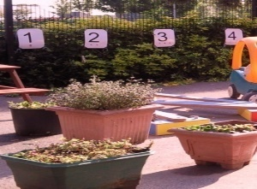
Please telephone us on 02380 764211 to let us know if you are going to be late. We have an answer phone; please leave a message as we regularly check for messages.

Persistent lateness will incur a charge.

Starting our Pre School

We want your child to feel happy and safe with us. To make sure that this is the case, our staff will work with you to decide on how to help your child to settle with us. Our policy on the Role of the Key Person and Settling-in is available to read on our website.

We hope that you and your child enjoy being members of our Pre School and that you both find taking part in our activities interesting and stimulating. Our staff are always ready and willing to talk with you about your ideas, views or questions.

To add your child to our register please complete a waiting list form, which is available on our website, can collect one in person or via email upon request.

Miscellaneous

Clothing

Children will get dirty- so dress for mess!

We advise children to wear soft clothing such as tracksuit bottoms/ leggings to make sure they are comfortable and can move freely.
If a child is toilet training jeans/ trousers with buttons can prevent their independence.

Please label all clothes so they don’t get lost.

We provide protective clothing for the children when they play with messy activities.
We encourage children to gain the skills that help them to be independent and look after themselves. These include using the toilet and taking off, and putting on, outdoor clothes. Clothing that is easy for them to manage will help them do this.
We like the children to be able to run about freely in our garden, to do this safely the children need sensible and sturdy shoes, therefore, we would advise that children do not wear flip flops or Crocs.

No Smoking

Our Pre-school and the grounds of the community school is a strict No Smoking site.

No Dogs are allowed on site either; please ensure you don’t bring any dogs near our Pre School gates.

Nappies

If your child is still using Nappies, please can you bring in spare nappies for each session in a labelled bag. We also return used nappies due to not having the facilities to dispose of them.

Text Messaging Service

We use a secure internet-based text messaging service called ‘teachers 2 parents’ to make quick and easy contact with you. These are usually information-based text messages. We cannot receive messages via this service.

Complaints

If a parent is unhappy with anything at pre – school please see Jo, our Manager. If the complaint is not dealt with to your satisfaction then it should be presented to the committee. Ofsted could be contacted if you are unhappy with the Committee. Ofsted phone number is on our notice board.

We have a Zero Tolerance policy for any verbal or physical abuse towards our staff, other parents and children.

Privacy notice
Redbridge Pre-school’s Privacy Notice
Redbridge Pre-school, c/o Redbridge Community School, Cuckmere Lane, Millbrook, Southampton, SO16 9RJ
info@redbridgepreschool.co.uk
Introduction
Personal data is protected in accordance with data protection laws and used in line with your expectations. This privacy notice explains what personal data we collect, why we collect it, how we use it, the control you have over your personal data and the procedures we have in place to protect it.
When we refer to “we”, “us” or “our”, we mean Redbridge Preschool.
What personal data we collect
We collect personal data about you and your child to provide care and learning tailored to meet your child’s individual needs. Personal details that we obtain from you includes your child’s: name, date of birth, address, and health, development and any special educational needs information. We will also ask for information about who has parental responsibility for your child and any court orders pertaining to your child.
Personal data that we collect about you includes: your name, home and work address, phone numbers, email address, emergency contact details, and family details.
We will only with your consent collect your national Insurance number or unique taxpayer reference (UTR) where necessary if you are self employed and where you apply for up to 30 hours free childcare and early education. We also collect information regarding benefits and family credits. Please note that if this information is not provided, then we cannot claim funding for your child.
We also process financial information when you pay your childcare and early education fees by chip and pin or direct debit. We may collect other data from you when you voluntarily contact us.
Where applicable we will obtain details of your child’s social worker, child protection plans from social care, and health care plans from health professionals and other health agencies.
We may collect this information in a variety of ways. For example, data will be collected from you directly in the registration form; from identity documents; from correspondence with you; or from health and other professionals.
Why we collect personal data and the legal basis for handling your data
We use personal data about you and your child in order to provide childcare and early education services and to fulfil the contractual arrangement you have entered into. This includes using your data in the following ways:
- to support your child’s wellbeing and development
- to effectively manage any special education, health or medical needs of your child whilst at the setting
- to carry out regular assessment of your child’s progress and to identify any areas of concern
- to maintain relevant contact about your child’s wellbeing and development
- to contact you in the case of an emergency
- to process your claim for free childcare and early education, if applicable
- to enable us to respond to any questions you ask
- to keep you updated about information which forms part of your contract with us
- to notify you of service changes or issues
- to send you our e-newsletter, if you have subscribed to it
With your consent, we would also like to:
- collect your child’s ethnicity and religion data for monitoring purposes
- record your child’s activities for their individual learning journal (this will often include photographs and videos of children during play)
- sign you up for our free parent e-newsletter which provides resources and useful information for parents
- transfer your child’s records to the receiving school when s/he transfers
If we wish to use any images of your child for training, publicity or marketing purposes we will seek your written consent for each image we wish to use. You are able to withdraw your consent at any time, for images being taken of your child and/or for the transfer of records to the receiving school, by confirming so in writing to the setting. You can also unsubscribe from receiving our parent e-newsletter by notifying the setting.
We have a legal obligation to process safeguarding related data about your child should we have concerns about her/his welfare.
Who we share your data with
As a registered early years provider in order to deliver childcare and early education services it is necessary for us to share data about you and/or your child with the following categories of recipients:
- Ofsted, when there has been a complaint about the childcare and early education service or during an inspection
- banking services in order to process chip and pin and/or direct debit payments
- the local authority, if you claim up to 30 hours free child care
- the governments eligibility checker as above, if applicable
- our insurance underwriter, where applicable
- an email newsletter service, where you have given consent to receive our e-newsletter
We will also share your data:
- if we are legally required to do so, for example, by a law enforcement agency, court
- to enforce or apply the terms and conditions of your contract with us
- to protect your child and other children; for example, by sharing information with medical services, social services or the police
- if it is necessary to protect our rights, property or safety or to protect the rights, property or safety of others
- with the school that your child will be attending, when s/he transfers, if applicable
- if we transfer the management of the setting out or take over any other organisation or part of it, in which case we may disclose your personal data to the prospective seller or buyer so that they may continue using it in the same way
Our nursery management and communication software provider may be able to access your personal data when carrying out maintenance task and software updates on our behalf. However, we have a written agreement in place which place this company under a duty of confidentiality.
We will never share your data with any organisation to use for their own purposes.
How do we protect your data?
We take the security of your personal data seriously. We have internal policies and strict controls in place to try to ensure that your data is not lost, accidentally destroyed, misused or disclosed and to prevent unauthorised access.
Where we engage third parties to process personal data on our behalf, they are under a duty of confidentiality and are obliged to implement appropriate technical and organisational measures to ensure the security of data.
Where do we store your data?
All data you provide to us is stored on secure computers or servers located within the UK or European Economic Area. We may also store paper records in locked filing cabinets.
Our third party data processors will also store your data on secure servers which may be situated inside or outside the European Economic Area. They may also store data in paper files.
How long do we retain your data?
We retain your data in line with our retention policy a summary is below:
- You and your child’s data, including registers are retained 3 years after your child no longer uses the setting, or until our next Ofsted inspection after your child leaves our setting.
- Medication records and accident records are kept for longer according to legal requirements.
- Learning journeys are maintained by the setting and available at your request when your child leaves. Records are kept and archived in line with our data retention policy.
- In some cases (child protection or other support service referrals), we may need to keep your data longer, only if it is necessary in order to comply with legal requirements. We will only keep your data for as long as is necessary to fulfil the purposes it was collected for and in line with data protection laws.
Your rights with respect to your data
As a data subject, you have a number of rights. You can:
- request to access, amend or correct the personal data we hold about you and/or your child
- request that we delete or stop processing your and/or your child’s personal data, for example where the data is no longer necessary for the purposes of processing or where you wish to withdraw consent
- request that we transfer your and your child’s personal data to another person
If you wish to exercise any of these rights at any time please contact the manager at the setting by email, telephone or when you attend the setting.
How to ask questions about this notice
If you have any questions, comments or concerns about any aspect of this notice or how we handle your data please contact the manager at the setting.
How to contact the Information Commissioner Office (ICO)
If the manager is not able to address your concern, please contact Redbridge Preschool Committee
If you are concerned about the way your data is handled and remain dissatisfied after raising your concern, you have the right to complain to the Information Commissioner Office (ICO). The ICO can be contacted at Information Commissioner’s Office, Wycliffe House, Water Lane, Wilmslow, Cheshire, SK9 5AF or https://ico.org.uk/.
Changes to this notice
We keep this notice under regular review. Any changes to this notice will be shared with you so that you may be aware of how we use your data at all times.

OUR CONTACT DETAILS

OFFICE 02380 764211

PRE SCHOOL-MOBILE 07432 83420439

EMAIL info@redbridgepreschool.co.uk

WEBSITE www.redbridgepreschool.co.uk

Your Comments

We value your comments, opinions, and ideas to help our Pre School and work in partnership with you.

If you would like us to know something but would prefer to write it, please feel free to write it down and pop it into our message box outside the office door.

Date_______________

Name (if you would like a reply) _____________________________________

_____________________________________________________________________________________________________________________________________________________________________________________________________________________________________________________________________________________________________________________________________________________________________________________________________________________________________________________________________________________________________________________________________________________________________________________________________________________________________________________________________________________________________________________________________________________________________________________________________________________________

Thank you for taking your time to read through our welcome pack. If you have any questions or queries, please ask a member of staff who will be happy to help.

Thank you again

From all the Staff and Committee at Redbridge Pre-School

