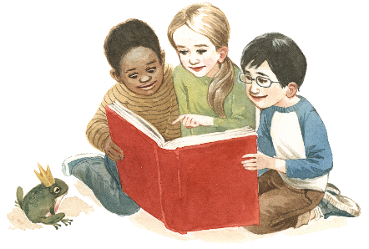
Book Club

Dear Parents and Guardians,

We are offering the chance for your child to borrow books so that you and your child can share stories together. You can change them as often as you like.
As you are aware, reading is a very important part of children’s development.
Here are some of the benefits…
- Build stronger relationship with you. Snuggling up with a book lets the two of you slow down and recapture that sweet cuddly time when your child was a baby. Reading can become a nurturing activity to bring you closer together.
- Basic speech skills. Pretend reading- when a toddler flicks through pages and squeals with delight it is a pre literacy activity. Preschoolers then begin sounding out words on their own, and become confident chatterboxes
- Better communication skills. When you spend time reading to your child, it helps them to be able to express themselves clearer and better able to relate to others in a healthier way.
- Enhanced concentration and discipline. Children will fidget and be distracted at first. As they get older they’ll learn to stay put for the duration of the time!
- The basics of how to read a book. Children aren’t born with an innate knowledge that text runs from left to right or that words on a page are separate from the images. Essential pre-reading skills like these are among the major benefits of early reading.
- Academic excellence. One of the primary benefits of reading to toddlers and preschoolers is higher aptitude for learning in general, they do some much better when they start primary school.
If you would like any other information. Please speak to Dawn.
Thank you

