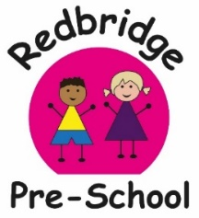
Our Exciting Enriching activities,
to promote Awe and Wonder
and help children’s Cultural Capital
What? | When?
Settling back in after Christmas | 4th -20th of Jan | Friendships.  Routines.  Fun!
Squirrel Appreciation Day  21st of January | 23rd-27th of Jan | We will be studying our squirrels that come into our garden.  Tally Charts, collage, pictures and stories  Home Challenge- If you spot a squirrel out with your child, pop a photo on Tapestry to get a certificate!
Friendship Celebrations | 30th Jan- 3rd Feb | Children will be celebrating their friendships, by making Friendship bracelets and thinking about what makes them special to each other, how to look after each other.
Children’s Mental Health Week | 6th -10th of February | Relaxing mood regulating activities,  Calming bubbles and sensory activities  What makes us happy, sad, cross?  YOGA sessions
Valentines Day  14th February | 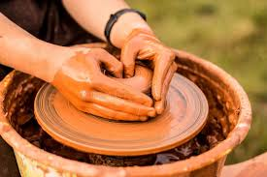  6th - 10th of February | Children will be talking about who they love and making pottery hearts.  We would love a small donation towards the cost of your child’s master piece
Half Term | 13th - 17th of February | Pre-school will be closed during this week.
Random Acts of Kindness day 17th Feb | 20th -24th of Feb  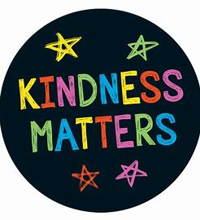 | This week along with pancakes we will be rewarding children and staff for their random acts of kindness! Who will be the kindness!
Pancake Day Tuesday 21st February | 20th-24th of Feb | Will be having pancakes for snack!  Traditional Story- The Runaway Pancake
World Book Day is the 3rd of March | 27th Feb-3rd of March  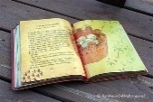 | Activities will be based around well known stories.  Fundraiser £1 donation and  Children may dress up as their favourite book character. This always enhances their play and is very popular.
Be a book worm! | From 27th of February | Home Challenge  Be a book worm.  How many books can your child read this week.  Fill out the form and who read with them to win a certificate!
Science week | 6th-10th of March | Making a rain cloud  Making a rainbow  Making a volcano  Floating/sinking, light/heavy
Mothers Day Shop  Mothers Day 19th | 13th- 17th of March | We will be running a Mothers day shop for children to buy gifts for loved ones. Letters to follow as we will need donations
Spring Equinox | 20th- 24th of March | Nature walks, Spring plant growth, exploring light and dark,  Meditation  Home Challenge- Take a selfie with the sunrise to get a super certificate!
YOGA | Morning and Afternoons 20th – 24th of March | Yoga for children. If your child would like to take part, please put them in soft comfortable clothes
Easter Craft Week | 27th-31st of March | Chick and rabbit decorations, Egg decorating, Chocolate nests
Parents Easter crafts | Tuesday 28th of March  2pm | Parent’s are welcome to come in to do some crafts with their child.
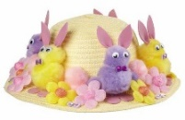  Easter Bonnett Parade | Wednesday 29th of March  Times to be confirmed | FUNDRAISER  This will be a sponsored walk, up to the local shop. Parent’s and grandparents welcome!.  Followed by an egg hunt at preschool
Last day of term | Friday 31st of March | Sessions will be as normal
End of Term Holiday | Mon 3rd of April-Friday 14thof April | Pre-school will be closed
Inset day and  Open afternoon  For New September 2022 children | Monday 17th of April | Pre-school will be closed to the children.
First Day Back for Summer term | Tuesday 18th of April | Pre-school sessions begin

MONEY RAISED FROM FUNDRAISING WILL GO TOWARDS OUR END OF YEAR TRIP TO PAULTONS PARK
Resources are tight this year, so to help with the cost of activities we would love and appreciate these items gifted to us if you have any spare…
We will need…
Science Experiments- Vinegar, shaving foam, flour, skittles (the sweets), bicaronate of soda, conditioner, food colouring.
Easter- Card, different coloured paper, tissue paper, Easter shapes, chicks, rabbits, collage and craft materials.
Mothers Day Shop- little gifty items, such as smellies, candles, ornaments, chocolates, so we can sell them for a small price.
Our super staff will also be doing other fun activities and clubs throughout the term to engage and extend the children’s learning

Dawn-Dancing with Nursery Rhymes Michelle- Meditation Groups
Mel-Cheerful Cheerleading Lisa- Listening Activities
Chelsea-Challenging Science Experiments Kelly- Crafts and Arts
Amelia-Emotional Wellbeing Jemma- Jolly Gymnastics

