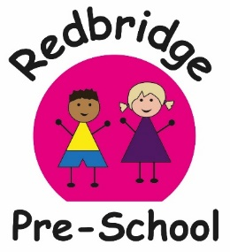
Our action packed term! Exciting Times!
Enriching Lives!

DATES FOR DIARIES
What? | When?
Settling In Activities | September | We will be doing various friendship activities to help the children learn each others names.
Harvest festival Soup Making  Week | 3rd -7th of October | The children will be peeling, chopping and cooking the vegetables for their own soup for snack!
World Smile Day | Friday the 7th of October | We will be singing the Laughing Song! Having a smiliest person competition and an award for the person who makes the most people smile!
Scarecrow making | 10th-14th of October | We will be making a Scarecrow at preschool this week. If you would like to join the fun and make one at home with your child we can display it!
Pumpkin Carving | 17th -21st of October | All donations of Pumpkins welcome! Any shape and any size.  Pumpkin rolling competition! Medal for the furthest roll!
Half Term Holiday | ^{24th} - 28th of October | Pre-school closed
First day back after half term | Monday 31st of October | Autumn 2
Trick or Treat?! | Monday31st of October  If your child is not in on this day they will be invited to a trick or treating session. | Spooky Happy Halloween! Children can come dressed up in their (friendly) Halloween outfits. Activities and Trick or Treating within pre-school.  £1 Donation gratefully received
CSR Falconry | Wednesday 2nd of November  At 9:00-10am | Claire will be bringing in a range of Owls and birds of prey for the children to see and hold.  If you would like to join in please pop along
Bonfire Night Light display | 3rd -4th November | Activities with Hot chocolate and marsh mallows.
Nature Collecting  What can we hear? What can we see? What can we find? | 7th-11th of November | If you go on your travels please collect different leaves, twigs and fir cones for us to investigate.
Pyjama and Popcorn Cosy movie afternoon | Friday 11th of November  afternoon | Children are welcome to wear their pj’s in the afternoon as the quiet room will be turned into cosy corner.  All other Pre-school activities will be open as usual.
Nursery Rhyme Week | 14th – 18th November | Activities will be based around rhymes Children will be focussing their play on characters from famous rhymes.  Children can come dressed as their favourite character throughout this week if they would like.
Sensory week | 21st-25th of November | Children will be exploring clay, foam, moon sand and lots more  Dress for Mess!
Photographer | Thursday 1st of December | Say CHEESE!  Hallets will be in to take your child’s portrait.
Christmas Lights Switch on | 1^{st-} 3rd of December | Preschool will be decked out with fairy lights and Christmas music for our Christmas sing song sessions around the tree!. So we can have a big countdown to switch on our twinkley lights!
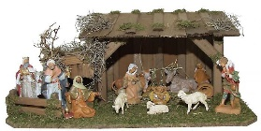  Mill Cottage Mobile Farm | 6th of DEC  10-12am  If its not your child’s normal session you are welcom to come and join the fun | We will have a visit from the Little Donkey and baby Jesus’s sheep for a wintery Christmas Stable Farm visit. Plus many more animals to hold and feel!  Plus Christmas Music and warm drinks.
Christmas Crafts | 1st -15th of December | Letters to Santa, tree decorations, Cristingles, calenders, biscuits,
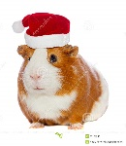  Christmas Dress up week | 12th- 16th of December | FUNDRAISER £1 donations will be gratefully received, to go towards our Summer Trip to Paulton’s Park.  Children are welcome to dress up
Festive snack | 12th – 16th December | Oranges, Turkey and Cranberry sauce Sandwiches, Mulled Juice.
Christmas Lunch | Wednesday 14th of December | Christmas Lunch and Christmas Crackers for lunchtime. Information to follow.  Donations of £1 per child welcomed!
Last day of term | Thursday 15th December | This is the last day of the children’s usual sessions
Jingle Bell Ball! Christmas Party for the children | Friday 16th of December  Times to be confirmed | Christmas Disco and tea party  Followed by a visit from Father Christmas  Invites to follow  We may try and do the Wriggley Nativity. We will let you know how we get on! ;0)
CHRISTMAS HOLIDAYS | 19th Dec- 2nd Jan
Inset Day-  No Pre-school | Tues 3rd of January | Pre-school is closed for the children
SPRING TERM  First Day Back after Christmas | Wed 4th of January

If anyone has any more enriching ideas we can do to promote our children’s learning experiences please let us know.

