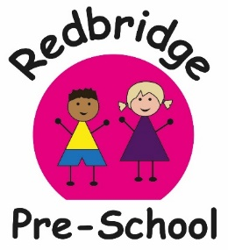
Our action packed term! Exciting Times!
Enriching Lives!

What? | When?
Harvest festival Soup Making  Week | 14th -18th of October | The children will be peeling, chopping and cooking the vegetables for their own soup for snack!
Scarecrow making | 21st – 25th of October | We will be making Scarecrows at preschool this week. If you would like to join the fun and make one at home with your child to bring in to display.
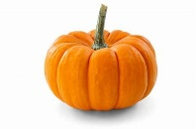  Pumpkin Carving | 21^{st-} 25th of October | All donations of Pumpkins welcome! Any shape and any size.  Pumpkin rolling competition! Medal for the furthest roll!
Photographer | Thursday 24th of October at 9am and 1pm | Say CHEESE! Cardwell and Simmons will be in to take your child’s portrait.  You are welcome to bring your child in to have their photo done if this is not their usual session.
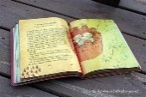  Story Time | Friday 25th of October at 11:15 | Parents are welcome to come in and join in with our end of session story or even read to the children if you would like!
Half Term Holiday | 28th- 1st of Nov | Pre-school closed  Back on 4th of November
 | To Be Confirmed | Jolene will be in for fun and whacky music and movement sessions  All children are welcome, if these sessions fall on your child’s day off please feel free to come in and join us.
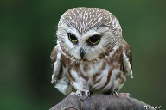  CSR Falconry | Wednesday 6th November  At 9:30 | Claire will be bringing in a range of Owls and birds of prey for the children to see and feel
Nature walk week  What can we hear?  What can we see?  What can we find? | 11th -15th of November | We will be taking the children out in small groups to the bushes and the tree to hunt for different leaves, plants and animals
Pyjama and Popcorn Cosy movie afternoon | Friday 15th of November  afternoon | Children are welcome to wear their pj’s in the afternoon as the quiet room will be turned into cosy corner.  All other Pre-school activities will be open
Nursery Rhyme Week | 18th-22nd November | Activities will be based around rhymes Children will be focussing their play on characters from famous rhymes.
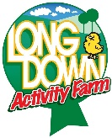  Long Down Activity Farm | Wednesday Morning the 4th of December | Christmas Stable theme- Farmer Ian will be bringing some animals for the children to see and hold
Christmas Crafts | Tuesday 10th of December from  10-11 am | You are welcome to pop along and make some Christmas crafts with your child
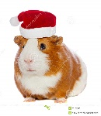  Christmas Dress up week | 16th- 20th of December | FUNDRAISER £1 donations will be gratefully received, to go towards our Summer Trip  Children are welcome to dress up
Christmas Lunch | Thursday 19th of December | Optional Christmas Lunch for the children who stay all day. Invites to follow. The cost will be £1 per child.
Last day of term | Thursday 19th December | This is the last day of the children’s usual sessions
Jingle Bell Ball! Christmas Party for the younger children | Friday 20th December  At 9:30-11:00 | Christmas Disco and tea party  Followed by a visit from Father Christmas  Invites to follow
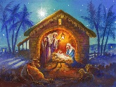  Christmas Disco, and Wriggly Nativity for the older children | Friday 20th December  At 12-1:30 | Christmas Party.  Followed by a visit from Father Christmas. Invites to follow
Inset Day- No Pre-school | Monday 6th of January | Pre-school is closed for the children
SPRING TERM  First Day Back after Christmas | Tuesday 7th of January
We welcome parents to come in to help or join in the fun with any of these sessions!

